(Approx. 327 words)

What version of Windows do I have?
By Rosita Herrick, Forum Leader, Sarasota Technology UG, FL
July 2018 issue, STUGMonitor
www.thestug.org
hrosita (at) aol.com

To check the version of Windows 10 that runs on your computer, do the following:

Press the Windows key and the letter R


When the display pops up, type in Winver and click on the OK box.

Windows will display the version and build running on your computer
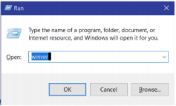

Here is what is running on my desktop:
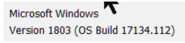

The 1803 means that I have the Spring update and the OS Build will change with every routine update when it is installed.

Of course, any time we get a major update, things change, and I am faced with having to learn new ways of doing things. Cortana has been updated to help users with the “How do I” questions. I have just started to use it, and I thought I would share my experience with our members.

Here are some examples:
When I typed: “How do I uninstall an app?” I got this popup:

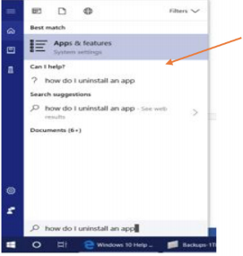

I clicked on the link and got the list of apps on my PC. When I clicked on the app I wanted to uninstall, I got the option you can see below.
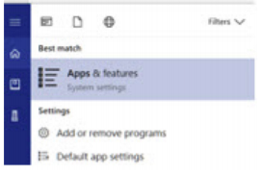
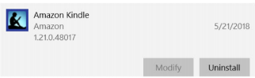

As you can see, all I need to do is click on the Uninstall box, and the system will do the rest. When I typed: “How do I check for updates?”,

I was directed to the Internet item displayed below:
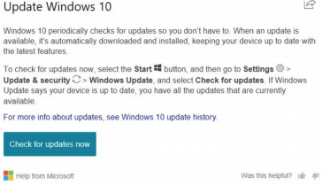

I do hope these tips help you navigate Windows 10 with less frustration.

